**ANALYSIS OF RESULT**

|  |  |
| --- | --- |
| **Dataset** | PLANT DISEASES |
| **Number of images** | 10410 |
| **Training Data** | 7282(70%) |
| **Validation Data** | 1569 (15%) |
| **Test Data** | 1569 (15%) |
| **Number of Epochs run** | 25 |
| **Optimizer** | Adam |
| **Average Accuracy** | 0.9018 |
| **Validation Accuracy** | 0.9261 |
| **Average Loss** | 0.2151 |
| **Validation Loss** | 0.1963 |
| **Batch Size** | 32 |
| **Loss Function** | categorical_crossentropy |
| **Momentum** | 0.9 |
| **Ir** | 0.01 |
| **Decay** | 1e-3 |
| **Nesterov** | True |

**Table representing the result**

## OUTPUT

**INPUT:**

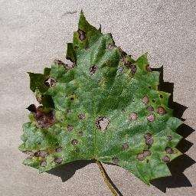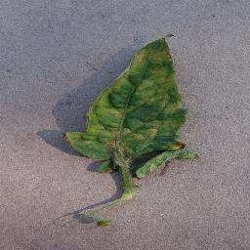

**OUTPUT:**



**Grape_ Black_rot Tomato Leaf_Mold**